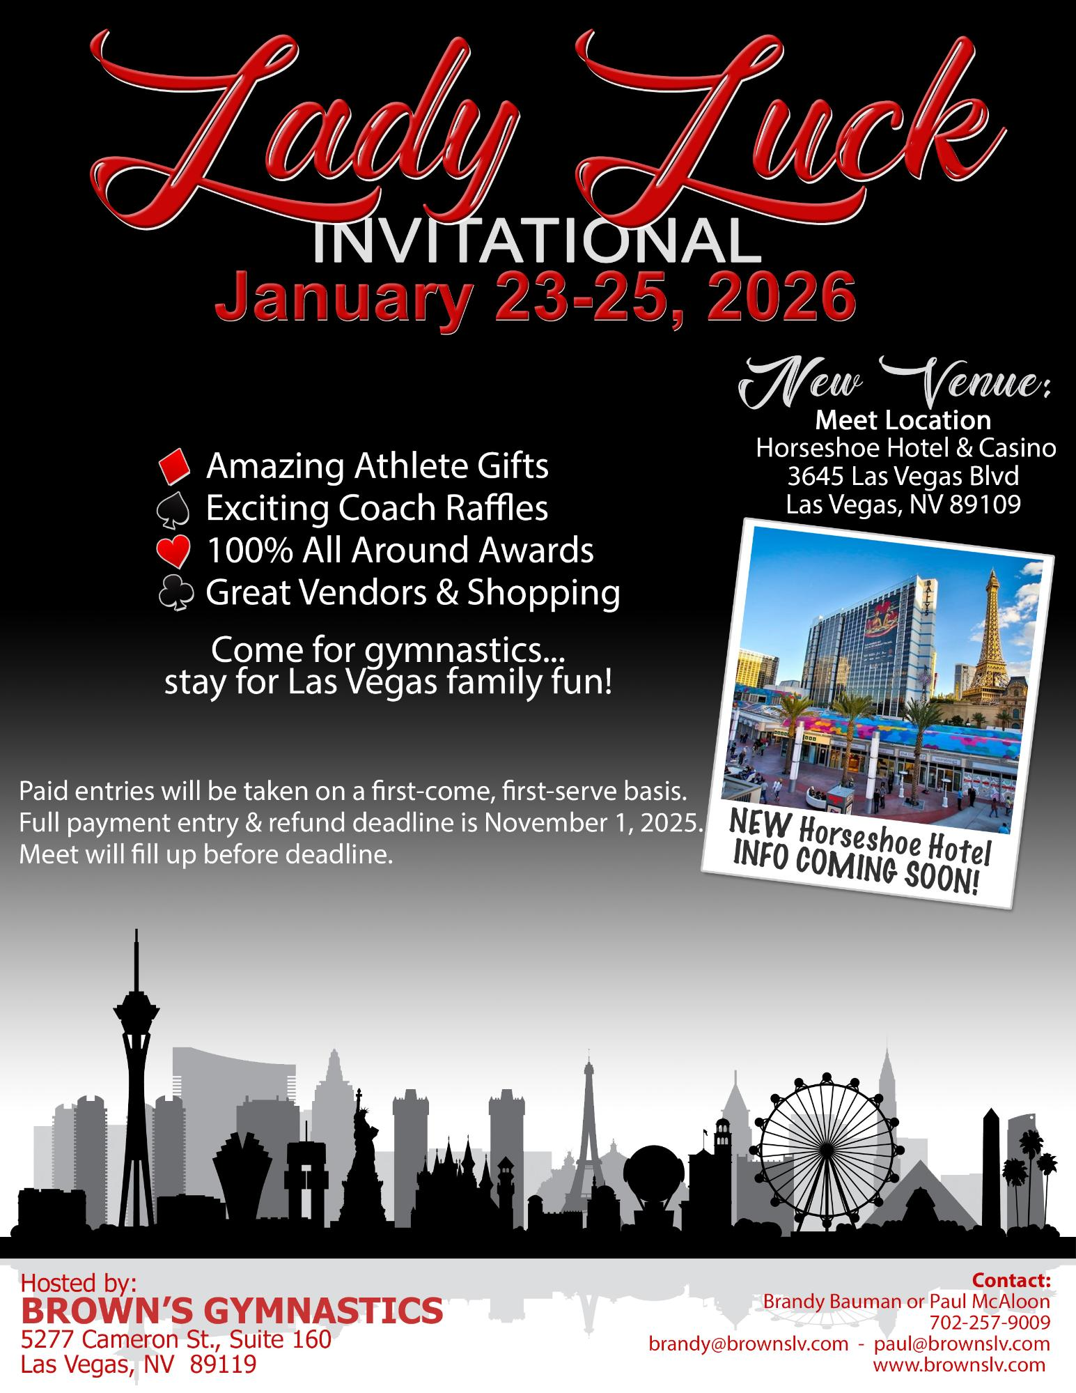
Lady Luck
INVITATIONAL January 23-25, 2026
Amazing Athlete Gifts Exciting Coach Raffles 100% All Around Awards Great Vendors & Shopping
Come for gymnastics... stay for Las Vegas family fun!
New Venue:
Meet Location
Horseshoe Hotel & Casino 3645 Las Vegas Blvd
Las Vegas, NV 89109
00006 1000
ANA OU
wearatie g
Paid entries will be taken on a first-come, first-serve basis.
Full payment entry & refund deadline is November 1, 2025. NEW Horseshoe Hotel
Meet will fill up before deadline.
INFO COMING SOON!
Hosted by:
BROWN'S GYMNASTICS 5277 Cameron St., Suite 160 Las Vegas, NV 89119
Contact:
Brandy Bauman or Paul McAloon
-
702-257-9009
brandy@brownslv.com - paul@brownslv.com
www.brownslv.com

